# Project Design Phase-II

**Data Flow Diagram & User Stories**

|  |  |
| --- | --- |
| Team ID | PNT2022TMID28606 |
| Project Name | Project - A Novel Method For Handwritten  Digit Recognition System |
| Maximum Marks | 4 Marks |

# Data Flow Diagrams:

A Data Flow Diagram (DFD) is a traditional visual representation of the information flows within a system. A neat and clear DFD can depict the right amount of the system requirement graphically. It shows how data enters and leaves the system, what changes the information, and where data is stored.

# Example: DFD Level 0 (Industry Standard)

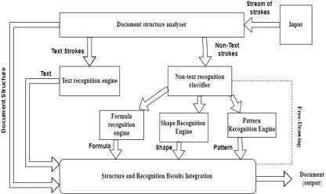

**Simplified diagram:**

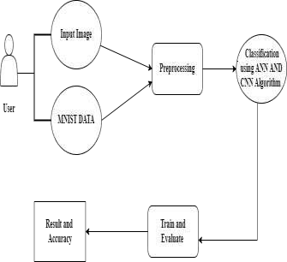

# User Stories

Use the below template to list all the user stories for the product.

|  |  |  |  |  |  |  |
| --- | --- | --- | --- | --- | --- | --- |
| **User Type** | **Functional Requirement**  **(Epic)** | **User Story Number** | **User Story / Task** | **Acceptance criteria** | **Priority** | **Release** |
| Customer (Mobile user) | Home | USN-1 | As a user, I can view the guide and awareness to use this application. | I can view the awareness to use this application and its limitations. | Low | Sprint-1 |
|  |  | USN-2 | As a user, I’m allowed to view the guided video to use the interface of this application. | I can gain knowledge to use this application by a practical method. | Low | Sprint-1 |

|  |  |  |  |  |  |  |
| --- | --- | --- | --- | --- | --- | --- |
|  |  | USN-3 | As a user, I can read the instructions to use this application. | I can read instructions also to use it in a user- friendly method. | Low | Sprint-2 |
|  | Recognize | USN-4 | As a user, In this prediction page I get to choose the image. | I can choose the image from our local system and predict the output. | High | Sprint-2 |
|  | Predict | USN-6 | As a user, I’m Allowed to upload and choose the image to be uploaded | I can upload and choose the image from the system storage and also in any virtual storage. | Medium | Sprint-3 |
|  |  | USN-7 | As a user, I will train and test the input to get the maximum accuracy of output. | I can able to train and test the application until it gets maximum accuracy of the result. | High | Sprint-4 |
|  |  | USN-8 | As a user, I can access the MNIST data set | I can access the MNIST data set to produce the accurate result. | Medium | Sprint-3 |
| Customer (Web user) | Home | USN-9 | As a user, I can view the guide to use the web app. | I can view the awareness  of this application and its limitations. | Low | Sprint-1 |
| **User Type** | **Functional Requirement**  **(Epic)** | **User Story Number** | **User Story / Task** | **Acceptance criteria** | **Priority** | **Release** |
| Customer (Mobile user) | Home | USN-1 | As a user, I can view the guide and awareness to use this application. | I can view the awareness to use this application and its limitations. | Low | Sprint-1 |

|  |  |  |  |  |  |  |
| --- | --- | --- | --- | --- | --- | --- |
|  |  |  |  |  |  |  |
|  |  | USN-2 | As a user, I’m allowed to view the guided video to use the interface of this application. | I can gain knowledge to use this application by a practical method. | Low | Sprint-1 |
|  |  | USN-3 | As a user, I can read the instructions to use this application. | I can read instructions also to use it in a user- friendly method. | Low | Sprint-2 |
|  | Recognize | USN-10 | As a user, I can use the web application virtually anywhere. | I can use the application portably anywhere. | High | Sprint-1 |
|  |  | USN-11 | As it is an open source, can use it cost freely. | I can use it without any payment to be paid for it to access. | Medium | Sprint-2 |
|  |  | USN-12 | As it is a web application, it is installation free | I can use it without the installation of the application or any software. | Medium | Sprint-4 |
|  | Predict | USN-13 | As a user, I’m Allowed to upload and choose the image to be uploaded | I can upload and choose the image from the system storage and also in any virtual storage. | Medium | Sprint-3 |